**VISVESVARAYA TECHNOLOGICAL UNIVERSITY**

**“Jnana Sangama”, Belagavi – 590 018**



**A MINI PROJECT REPORT**

**On**

**“Automatic License Plate Recognition System”.**

*Submitted in partial fulfillment of the requirements for the award of degree*

Bachelor of Engineering   
 In

**COMPUTER SCIENCE ENGINEERING**

Submitted by

**Soham Rao (1BG23CS154)  
 Suhas R (1BG23CS162)  
 Tanish Jain (1BG23CS167)**   
 **Tanmay Anand (1BG23CS168)**

Under the guidance of

**Dr. Anitha N**

Professor



*Vidyaya Amrutham Ashnuthe*

**DEPARTMENT OF COMPUTER SCIENCE**

**Approved by AICTE, affiliated to VTU, Accredited as Grade A Institution by NAAC.**

**All UG branches – CSE, ECE, EEE, ISE & Mech.E Accredited by NBA for academic years 2018-19 to 2020-21 & valid upto 30.06.2021**

**Post box no. 7087, 27th cross, 12th Main, Banashankari 2nd Stage, Bengaluru- 560070, INDIA Ph: 91-80- 26711780/81/82 Email:** [**principal@bnmit.in,**](mailto:principal@bnmit.in) [**www.**](http://www/) **bnmit.or**

**Approved by AICTE, Affiliated to VTU, Accredited as Grade A Institution by NAAC.**

**All UG branches – CSE, ECE, EEE, ISE & Mech.E Accredited by NBA for academic years 2018-19 to 2020-21 & valid upto 30.06.2021**

Post box no. 7087, 27th cross, 12th Main, Banashankari 2nd Stage, Bengaluru- 560070, INDIA Ph: 91-80- 26711780/81/82 Email: [principal@bnmit.in,](mailto:principal@bnmit.in) [www.](http://www/) bnmit.org

**DEPARTMENT OF COMPUTER SCIENCE AND ENGINEERING**

*Vidyaya Amrutham Ashnuthe*

**CERTIFICATE**

This is to certify that the Mini project work entitled “Automatic License Plate Recognition System” has been successfully completed and is a bonafide work carried out by **Mr. TANMAY ANAND, USN: 1BG23CS168, Mr SOHAM RAO, USN:1BG23CS154, Mr. SUHAS R, USN: 1BG23CS162, Mr. TANISH JAIN, USN: 1BG23CS167** bonafide student**s** of IV Semester B.E., B.N.M. Institute of Technology, an Autonomous Institution under Visvesvaraya Technological University, Belagavi submitted in partial fulfilment for the award of **Bachelor of Engineering** in **COMPUTER SCIENCE AND ENGINEERING**, during the year 2024-25. It is certified that all corrections / suggestions indicated for Internal Assessment have been incorporated in the Report. The report has been approved as it satisfies the academic requirements in respect of project work prescribed for the said degree.

|  |  |  |  |  |
| --- | --- | --- | --- | --- |
| **Dr. Anitha N** | **Dr. Chayadevi M L** | | **Dr. S Y Kulkarni** | |
| Professor, | Professor and HOD, | | Additional Director | |
| Dept. of CSE, | Dept. of CSE, | | and Principal, | |
| BNMIT, Bengaluru  **Name**    **Examiner 1:**  **Examiner 2:** | | | BNMIT, Bengaluru | | BNMIT, Bengaluru  **Signature with Date** | |

# ACKNOWLEDGEMENT

I take this opportunity to express my heartfelt gratitude to all those who supported and guided me throughout the development of this project, the Automatic License Plate Recognition System. Their

contributions and encouragement were invaluable to the successful completion of this endeavor.

First and foremost, I would like to extend my sincere thanks to the Dean of our institution,   
Prof.   Eishwar N Maanay, for providing the resources and a conducive environment to undertake this project. Their constant support and emphasis on innovation inspired me to push my boundaries.

I am immensely grateful to our Head of the Department, Dr. Chayadevi M.L, Professor, Dept. of CSE, for their unwavering            support and guidance. Their insights and suggestions played a crucial role in shaping the direction of this project. Their encouragement throughout the process has been a source of great motivation.

A special note of appreciation goes to my Guide, Dr. Anitha N, Professor, for her invaluable mentorship, technical expertise, and constructive feedback. Their patient guidance, timely advice, and constant encouragement helped me overcome challenges and refine the project to its current form.

I also wish to express my deepest gratitude to my parents for their unconditional love, support, and encouragement throughout this journey. Their belief in my abilities has been my greatest strength, and their words of motivation have always driven me to excel.

Lastly, I would like to thank my peers, friends, and everyone who contributed directly or indirectly to the successful completion of this project. Your encouragement and suggestions have   been instrumental in making this project a success.

This project would not have been possible without the collective support of everyone mentioned above. I am truly grateful for their contributions and look forward to utilizing the knowledge and skills gained from this experience in future endeavors.

# ABSTRACT

Utilizing advanced deep learning and optical character recognition (OCR), the Automatic License Plate Recognition System (ALPERS) delivers an automated solution for detecting and recognizing license plates on a Raspberry Pi. The system employs the EasyOCR library to extract text from detected license plates and a pre-trained YOLOv8 model, exported to a TensorFlow Lite (TFLite) format, to identify license plates in real-time video streams or images. The primary aim is to provide a scalable, reliable, and efficient license plate recognition system deployable in diverse scenarios, such as automated parking systems, traffic management, and security applications.

The detection process leverages real-time video frame capture and image input on the Raspberry Pi, with the YOLOv8 TFLite model accurately identifying license plate regions. Bounding boxes are drawn around detected plates, and the system pauses briefly to ensure stability before initiating the OCR process. EasyOCR then extracts the alphanumeric characters from the license plates, storing results with time-stamped entries for subsequent analysis. Robustness is ensured through dropout algorithms and high-confidence thresholds, effectively filtering erroneous detections and minimizing false positives.

This study demonstrates the practical application of sophisticated machine learning and image processing techniques to solve real-world challenges on resource-constrained devices. The modular architecture, optimized for the Raspberry Pi, supports potential enhancements like multi-language compatibility or integration with cloud-based storage for large-scale deployments. The system’s real-time performance, processing efficiency, and recognition accuracy highlights its value as a vital tool in modern traffic monitoring and management systems.

# TABLE OF CONTENTS

|  |  |  |  |
| --- | --- | --- | --- |
| **Chapter No.**  **1.** |  | **DESCRIPTION**  **INTRODUCTION** | **Page No.** |
|  | 1.1 | Motivation | 10 |
|  | 1.2 | Problem Statement | 11 |
|  | 1.3 | Objective | 11 |
| **2.** | 1.4 | Summary  **LITERATURE SURVEY** | 12 |
|  | 2.1 | Existing Platforms And Their Features | 14 |
|  | 2.2 | Research Papers And Studies Reviewed | 15 |
|  | 2.3 | Pros And Cons Of Existing Platforms | 16 |
| **3.** | 2.4 | Insights From The Literature Survey  **SYSTEM REQUIREMENTS** | 16 |
|  | 3.1 | Hardware Requirements | 18 |
| **4.** | 3.2 | Software Requirements  **SYSTEM DESIGN AND DEVELOPMENT** | 19 |
|  | 4.1 | Block Diagram | 21 |
|  |  |  |  |

|  |  |  |
| --- | --- | --- |
|  | 4.2 Methodology |  |

* + 1. Development Approach 22
    2. Design Process 23
    3. Implementation Steps 23
    4. Deployment And Maintenance 23

4.2.5 Advantages Of The Methodology 23

1. IMPLEMENTATION
   1. User Interface Module 25
   2. Plate Detection Module 26
   3. Text Extraction Module 27
   4. MQTT – Subscriber Module 28
   5. MQTT – Publisher Module 29
2. TESTING
   1. User Interface Module 32
   2. Plate Detection Module 33
   3. Text Extraction Module 33
3. RESULTS

7.1 Car Plate Detection 35

7.2 Car Plate OCR 35

7.3 Car Plates Uploaded 36

1. CONCLUSION AND FUTURE ENHANCEMENT
   1. Future Enhancement 38
   2. Conclusion 39

REFERENCES 40

**List of Figures**

|  |  |  |
| --- | --- | --- |
| **Figure No.** | **Description** | **Page No.** |
| **4.1** | Block Diagram | **21** |
| **6.1** | User Interface Module | **25** |
| **6.2** | Plate Detection Module | **26** |
| **6.3** | Text Extraction Module | **27** |
| **7.1** | Car Plate Detection | **35** |
| **7.2** | Car Plate OCR | **35** |
| **7.3** | Car Plate Uploaded | **36** |

# List of Tables

|  |  |  |
| --- | --- | --- |
| **Table No.** | **Description** | **Page No.** |
| **2.1** | Pros and Cons of Existing Systems | **15** |

**CHAPTER 1  
INTRODUCTION**

**CHAPTER 1**

**INTRODUCTION**

# Motivation:

The necessity for automated technologies to effectively monitor vehicle actions has been brought to light by the growing complexity of contemporary transportation systems. The increasing number of automobiles is too much for traditional manual techniques, which are frequently slow and prone to errors. The requirement for a dependable, scalable, and real-time license plate detection and recognition system that boosts public safety, traffic management, and automated parking process optimization is what spurred this project. This system seeks to minimize human intervention, minimize errors, and provide an intelligent answer to contemporary transportation difficulties by leveraging cutting-edge deep learning and optical character recognition (OCR) technologies.

* + - **Enhancing Traffic Management Efficiency:** The manual techniques of monitoring and controlling traffic offenses have grown ineffective due to the growing number of vehicles on the road. Law enforcement agencies' workload can be decreased, fines can be issued, and offenses can be tracked with the help of automated license plate recognition. This system provides a dependable and scalable way to monitor traffic in real time.
    - **Leveraging IoT and Edge Computing for Affordable Solutions:** The proliferation of IoT and edge computing has created opportunities for cost-effective, real-time automation in transportation systems. By deploying the Automatic License Plate Recognition System on a Raspberry Pi, this project capitalizes on the Pi’s affordability and portability to deliver a scalable, edge-based solution for license plate detection, enabling seamless integration into IoT ecosystems for traffic management, security, and parking automation.
    - **Facilitating Automated Parking Systems :** In order to meet the growing demand in metropolitan areas, modern parking systems must operate seamlessly. By managing parking lot entry, exit, and payment procedures without the need for human intervention, automated license plate recognition enhances customer experience and operational effectiveness.
    - **Encouraging Innovation in AI and Image Processing :** This project serves as a practical application of AI and image processing technologies, showcasing their potential to solve real-world problems. It also motivates further research into improving detection accuracy, OCR capabilities, and system scalability for more complex environments.

The urgent requirement for automatic and effective license plate identification in contemporary transportation networks is addressed by this project. It provides a scalable way to improve automation, security, and traffic management by combining AI with image processing. In the end, it seeks to lessen human mistake and offer creative answers to problems encountered in the actual world.

# Problem Statement

Develop an affordable solution leveraging image processing techniques on a Raspberry Pi platform for the detection, identification, and monitoring of vehicle number plates in various scenarios. These include residential societies, toll booths, business complexes, parking facilities, and other areas requiring efficient vehicle management.

# Objectives

* **Implement EasyOCR for Text Recognition**: Use EasyOCR, a robust optical character recognition library, to extract textual information from detected license plates.
* **Support Different Font Styles**: Adapt the OCR system to recognize license plates with varying fonts, styles, and custom characters, improving versatility.
* **Increase Robustness in Varied Lighting Conditions**: Enhance the system's performance under different environmental conditions, such as low light, direct sunlight, or nighttime, ensuring consistent accuracy in plate recognition.
* **Enable Detection in Complex Environments**: Adapt the YOLO model to work effectively in complex and dynamic environments, such as busy traffic areas or parking lots, where multiple vehicles are detected simultaneously.
* **Optimize System Deployment on Raspberry Pi:** Configure and enhance the system for efficient operation on a Raspberry Pi, leveraging edge computing to ensure real-time performance in resource-constrained environments.

# Summary

This chapter introduces the Automatic License Plate Recognition System (ALPERS), emphasizing its deployment on a Raspberry Pi for edge-based, real-time plate detection. The motivation highlights the need for high-accuracy, affordable solutions in today’s interconnected world, leveraging IoT and AI to address transportation challenges.

# CHAPTER 2 LITERATURE SURVEY

# CHAPTER 2 LITERATURE SURVEY

The design and development of the Automatic License Plate Recognition System was informed by an extensive literature survey of existing systems, tools, and frameworks that facilitate plate detection. The focus was on identifying both the strengths and limitations of existing solutions, which guided the enhancements proposed in this project.

# Existing Platforms and Their Features

## OpenALPR

OpenALPR provides cloud-based and on-premise solutions for automatic license plate recognition. The platform offers a user-friendly interface for monitoring and managing plate data. However, it lacks accuracy, since it measures sharp drops in low light or extreme weather conditions. It may struggle with international plate formats or regions with less standardized plates. The cloud-based service may introduce latency or data privacy concerns for sensitive applications.

## PlateSmart

PlateSmart is a robust ANPR (Automatic Number Plate Recognition) software that works with existing CCTV infrastructure. The system is expensive and may not be cost-effective for small-scale deployments. It requires powerful hardware for optimal performance, leading to higher installation costs. It is not always compatible with older or lower-quality surveillance camera systems..

## Sentry AI

Sentry AI uses machine learning models to detect and recognize license plates in real-time. The system’s accuracy can be affected by external factors like rain or fog. It may require frequent model updates to handle new plate designs or changes in environmental conditions. These are significant drawbacks of this system.

## 

## Research Papers and Studies Reviewed

* + 1. **“Automatic License Plate Recognition (ALPR): A State-of-the-Art Review”, 2017 [1]**

This paper reviews the development and techniques used in ALPR systems, including optical character recognition (OCR), image preprocessing, and deep learning methods. It provides an overview of various algorithms, focusing on challenges such as illumination variation, plate distortion, and noise in the image. The paper also discusses the role of machine learning, specifically convolutional neural networks (CNNs), in improving the accuracy of ALPR systems. It highlights future trends in ALPR, including the integration of AI for better scalability and accuracy.

## “License Plate Recognition using YOLOv4 and Deep Learning for Vehicle Tracking”, 2018 [2]

This paper explores the use of YOLOv4 (You Only Look Once) for real-time license plate detection and recognition. It focuses on leveraging the speed and accuracy of YOLOv4 for vehicle tracking and license plate recognition in complex urban environments. The study highlights the performance improvements over traditional methods and the effectiveness of YOLOv4 in handling multiple vehicles in real-time video feeds. It also presents results from experiments on various public datasets, demonstrating the model's robustness and efficiency.

## “A Survey of License Plate Recognition Algorithms and Applications”, 2019 [3]

This research paper surveys different techniques and methodologies for license plate recognition, including feature extraction, template matching, and deep learning-based approaches. The paper categorizes the various approaches based on their application domains such as security, parking management, and traffic law enforcement. It also examines the challenges faced by ALPR systems, such as environmental factors (weather, lighting), plate design variations, and occlusions. The paper emphasizes the importance of integrating machine learning techniques for real-time, accurate plate recognition in diverse environments.

## Pros and Cons of Existing Systems

Table 2.1: Pros and Cons of Existing Systems

|  |  |  |
| --- | --- | --- |
| **Platform/Study** | **Pros** | **Cons** |
| OpenALPR | Cloud based solution, user friendly interface. | Struggles with international plate formats. |
| PlateSmart | Works with existing CCTV infrastructure. | High cost, requires very powerful hardware. |
| SentryAI | Robust, mobile-friendly app. | Affected by external factors such as fog and rain. |

* 1. **Insights from the Literature Survey**

The literature survey revealed the following insights:

* CNNs and models like YOLO have greatly improved ALPR accuracy, handling variations in plates, lighting, and angles with real-time detection.
* Poor lighting and weather affect accuracy; image preprocessing and data augmentation help mitigate these issues.
* Transfer learning with models like YOLO and ResNet boosts performance, enabling quick deployment with limited data.
* Using additional sensors like infrared cameras improves accuracy in low-light environments, enhancing ALPR reliability.

# CHAPTER 3

# SYSTEM REQUIREMENTS

# CHAPTER 3

# SYSTEM REQUIREMENTS

**3.1 Hardware Requirements**

To ensure seamless operation and optimal performance of the Automatic License Plate Recognition System on an edge device, the following hardware components are recommended:

* **Processor**:   
  A Raspberry Pi 4 Model B (1.5 GHz quad-core ARM Cortex-A72) or Raspberry Pi 5 (2.4 GHz quad-core ARM Cortex-A76) is advised, delivering a balanced blend of efficiency and computational power for real-time processing. These processors support multi-core operations, crucial for handling the demands of YOLOv8n inference and image processing in edge environments.
* **GPU**:  
  Not applicable, as the system relies solely on CPU-based processing. The YOLOv8n model is optimized for low-resource execution on the Raspberry Pi, eliminating the need for a dedicated GPU while maintaining effective license plate detection and text extraction performance.
* **RAM**:   
  A minimum of 4GB RAM is required to support concurrent processes, such as video stream handling and database operations, without performance degradation. An 8GB configuration is recommended for enhanced multitasking, ensuring smooth execution of complex algorithms and data queries.
* **Storage Requirements**:   
  A 32GB Class 10 microSD card, with at least 50MB free, is necessary for software installation and core operations. Additional storage may be needed for captured images, SQL databases, and logs, with optional USB-connected SSDs preferred for faster read/write speeds to accommodate larger datasets.

**3.2 Software Requirements**

The system relies on a suite of advanced machine learning frameworks, OCR tools, and user interface libraries to deliver accurate and user-friendly functionality:

* **Machine Learning Model:**
  + **Ultralytics-YOLO-v8:**  
    A state-of-the-art object detection framework, YOLO (You Only Look Once) version 8 is employed for detecting and localizing license plates in real-time. Its high accuracy and speed make it ideal for dynamic environments such as traffic monitoring.
  + **PyTorch:**  
    This deep learning framework is used to build, train, and deploy the YOLO v8 model. PyTorch’s flexibility and GPU support make it well-suited for machine learning tasks.
  + **Nvidia-CUDA:**  
    For systems equipped with an Nvidia GPU, CUDA is used to leverage the GPU’s parallel processing capabilities, drastically speeding up the model’s inference and processing times.
* **Text Extraction:**
  + **EasyOCR:**  
    This Python-based OCR tool specializes in extracting text from images. It is used to accurately recognize and extract alphanumeric characters from license plates, even in challenging conditions like poor lighting or distorted plates.
* **Frontend:**
  + **CustomTkinter:**  
    This modern user interface library for Python allows developers to create a responsive and visually appealing GUI for the system. It simplifies interaction with the software by providing an intuitive interface for users to upload images, view results, and manage data.

All the aforementioned libraries and frameworks are implemented using **Python**, ensuring a cohesive and easily maintainable development environment. Python’s extensive library support and active community make it an ideal choice for developing machine learning and GUI-based applications.

# CHAPTER 4

**SYSTEM DESIGN AND DEVELOPMENT**

# CHAPTER 4

**SYSTEM DESIGN AND DEVELOPMENT**

# Block Diagram

Fig 4.1: Block Diagram

Figure 4.1 illustrates the workflow of the Automatic License Plate Recognition System deployed on a Raspberry Pi. The process begins with two input sources: **Live Video Feed** from a Raspberry Pi Camera (e.g., Module v3 or Global Shutter) and **Static Image Input** stored on the microSD card, serving as entry points for real-time or pre-captured data.

The next step, depicted in Figure 4.1, is the **Image Detection Model**, where a YOLOv8n model, exported to TensorFlow Lite (TFLite) format, identifies and localizes license plates within the input. This step outputs the Detected License Plate for further processing on the Raspberry Pi’s ARM CPU.

Following this, the **Image Preprocessing stage** (Fig. 4.1) enhances the detected license plate image through operations like noise reduction, resizing to 320x320, and contrast adjustments, optimizing image quality for text recognition in resource-constrained environments.

In the **Optical Character Recognition** (OCR) step, shown in Figure 4.1, the enhanced image is processed by EasyOCR to extract readable text, such as alphanumeric characters, from the license plate. EasyOCR’s robustness ensures accurate recognition under varied conditions.

The **Database Storage block** in Figure 4.1 saves the extracted text, along with metadata like timestamps, into an SQL database, tailored for efficient storage on the Raspberry Pi. Finally, the Data Retrieval stage, as illustrated in Figure 4.1, enables querying and accessing stored data, supporting IoT applications like vehicle tracking and traffic management.

* 1. **Methodology**

The development of the Automatic License Plate Recognition System follows a structured methodology, as depicted in Figure 4.1, integrating modern software engineering practices and iterative development cycles. This approach ensures the system is scalable, efficient, and tailored for edge deployment on a Raspberry Pi, meeting the needs of IoT applications in vehicle management.

# Development Approach

## Requirement Analysis

The project began with a detailed requirement analysis to identify the key functionalities needed in the platform. This phase included:

* + - * + Gathering feedback from car owners, parking structure owners, apartments.
        + Reviewing existing systems to understand their strengths and limitations.
        + Defining the primary modules: Plate Detection, Text Extraction, User Interface.
      1. **Technological Stack**
         * **Frontend:** Python’s CustomTkinter
         * **Backend:** Python.
         * **Database:**SQL
         * **Containerization:** Docker
         * **Camera Interface:** picamera2 for Raspberry Pi Camera Module

# Design Process

## User-Centered Design

The user interface(UI) was designed for simplicity and efficiency, prioritizing headless operation for IoT use. The process involved

* + - * + **Prototyping:** Developing interactive prototypes in Figma to gather feedback on the design.
        + **Edge-Optimized Design:** Ensuring compatibility with Raspberry Pi’s ARM architecture and low-resource environments.

## Security Considerations The ML model has been meticulously trained in order to recognize only authentic license plates after scrutinizing and ensuring that the confidence threshold is greater than 70%. This ensures that no invalid license plate is detected for any malicious reasons.

# Implementation Steps

## Modular Development

The platform was divided into distinct modules, each developed and tested independently:

* + - * + **Camera Capture Module:** Utilizes picamera2 to acquire 320x320 frames from Raspberry Pi Camera modules for real-time processing
        + **Plate Detection Module:** Employs YOLOv8n TFLite to detect plates, drawing bounding boxes and applying filters for enhanced accuracy.
        + **Text Extraction Module:** Extracts text from the detected plate.

## Integration

After module development, integration testing ensured seamless interaction between components. For example:

* + - * + Frame capture requests from the camera module triggered real-time detection.
        + Detected plates were processed by EasyOCR, with results stored in SQL for querying.

## Testing and Feedback

The platform underwent rigorous testing to validate the performance on the Raspberry Pi:

* + - * + **Unit Testing:** Verifying individual components (e.g., camera capture, plate detections).
        + **Integration Testing:** Ensuring modules work together without conflicts.
        + **User Testing:** Gathering feedback from a pilot group of structure owners and different parking lot complexes.

# Deployment and Maintenance

## Monitoring and Updates Continuous monitoring ensures the system operates reliably under different conditions. Key activities include tracking performance metrics such as accuracy and frame rate, maintaining error logs for troubleshooting, and optimizing performance on the Raspberry Pi.

* + - * + **Feedback Loop:** Incorporating user feedback to refine features and enhance IoT functionality.

# Advantages of the Methodology

* **Iterative Development:** Ensures continuous improvement based on real-world edge deployment feedback.
* **Scalability:** The use of lightweight TFLite models and SQL supports expansion for IoT ecosystems.
* **Edge-Centric Design:** Prioritizes efficiency and portability for Raspberry Pi-based applications.
* **Security and Reliability:** Incorporating user feedback to refine features and enhance IoT functionality.

# CHAPTER 5 IMPLEMENTATION

# CHAPTER 5 IMPLEMENTATION

# User Interface Module

Initialize LicensePlateApp class:

Configure main window size, title, and centered position

Set gradient background and disable resizing

Call initialize_ui()

Define initialize_ui():

Add title label with "ALPERS"

Add button for "Capture from Image" -> open_image_capture_window()

Add button for "Capture from Video" -> run_video_capture()

Define open_image_capture_window():

Open a small popup window

Add label prompting user to select an image

Add "Browse" button to open file dialog

On image selection, execute image recognition script

Define run_video_capture():

Execute video recognition script

Main Execution:

Instantiate LicensePlateApp

Start application main loop

Fig 5.1: Pseudocode for User Interface

# Plate Detection Module

Fig 5.2: Pseudocode for Plate Detection

Import YOLO and OS modules

Set environment variable to prevent errors

Initialize YOLO model with pre-trained weights

Set multiprocessing to spawn mode for compatibility

Move model to GPU for faster processing

Start training with:

Data configuration file

1 epoch

Batch size of 8

Workers set to 0

Load the best-trained model from training outputs

Run inference on test images and save results

Fig 5.2: Pseudocode for Plate Detection

# Text Extraction Module

Initialize multiprocess settings and environment variables

Initialize EasyOCR reader and load YOLO model

Check if camera opens successfully; exit if not

Set up file paths and thresholds for confidence and timers

Start video stream loop:

Capture frame; exit if capture fails

Save current frame to file

Run YOLO inference on the frame

For each detection:

Extract bounding box and confidence values

Draw bounding box and confidence label on the frame

If confidence above threshold:

Start/save timer for OCR if not already started

If timer expires, run OCR on detected plate

Extract and save recognized text with timestamp

Mark OCR as done

If confidence below drop threshold:

Reset OCR and timer flags

Display processed frame with detection

Exit loop if 'q' key is pressed

Release camera and clean up temporary files

Fig 5.3: Pseudocode for Text Extraction

# MQTT – Subscriber Module

main

read config from config_pub.json

connect to MongoDB using config.db_host, config.db_port, config.db_name, config.db_collection

initialize MQTT client

set on_connect to print connection status and subscribe to "license/plate"

set on_message to decode payload, add topic and timestamp, store in MongoDB, print payload

set on_disconnect to print disconnection status

connect MQTT client to config.broker_host, config.broker_port

start MQTT loop

while true

pass

if KeyboardInterrupt

disconnect MQTT client

stop MQTT loop

print subscriber stopped

Fig 5.4: Pseudocode for Subscriber

# MQTT – Publisher Module

main

last_seen_plate = null

min_similarity = 85

send_plate_to_mqtt(plate_text, confidence)

if last_seen_plate and fuzzy_ratio(plate_text, last_seen_plate) >= min_similarity

print skipped duplicate

return

last_seen_plate = plate_text

payload = {plate: plate_text, confidence: float(confidence)}

publish payload to "license/plate" on localhost:1883

print sent payload

Fig 5.5: Pseudocode for Publisher

The figure 5.1 outlines a video stream pipeline for license plate recognition. It initializes the environment, YOLO model, and EasyOCR, ensuring the camera is operational. Frames are captured, YOLO detects objects, and OCR is performed on plates with high-confidence detections, saving recognized text with timestamps. It handles resetting timers and flags for low-confidence cases and displays processed frames until the loop exits.

The 5.2 details YOLO model training and inference. It initializes the model with pre-trained weights, configures multiprocessing, and trains it using specified parameters such as epochs and batch size. After training, the best-performing model is loaded to run inference on test images, with the results saved for further analysis.

The 5.3 describes a GUI application for license plate recognition, LicensePlateApp. It sets up the main window with a title, gradient background, and buttons for image and video capture. Selecting an image triggers recognition, while the video option runs real-time detection. The app provides a user-friendly interface for seamless plate detection workflows.

The 5.4 describes the working of the subscriber with Paho MQTT library and PyMongo library.

The 5.5 describes the working of the publisher with Paho MQTT library and Fuzzy library.

# CHAPTER 6 TESTING

# CHAPTER 6 TESTING

# User Interface Module

Fig 6.1: User Interface Module

The above figure 6.1 shows the User Interface Module which provides the user with two options to capture the data, i.e, Capture from Image, and Capture from Video.

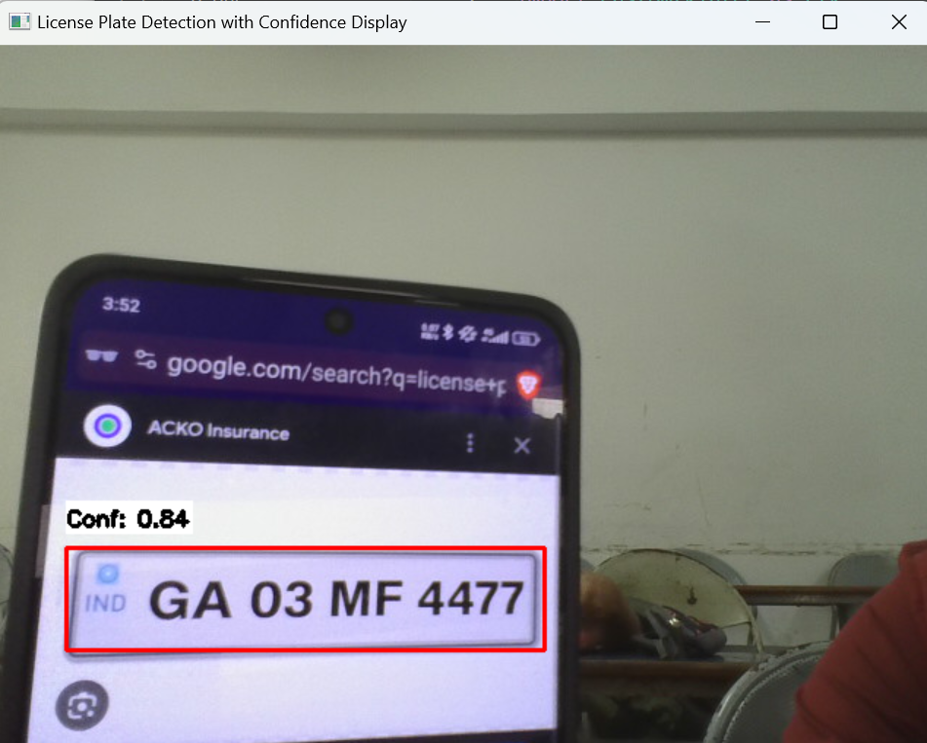 **6.2 Plate Detection Module**

Fig 6.2: Plate Detection Module

The above figure 6.2 shows a plate being detected by the Plate Detection Module through the live video feed.

**6.3 Text Extraction Module**



Fig 6.3: Text Extraction Module

The above figure 6.3, shows the text being extracted from the detected license plate, using the Text Extraction Module.

# CHAPTER 7 RESULTS

# CHAPTER 7 RESULTS

# 7.1 Car Plate Detection

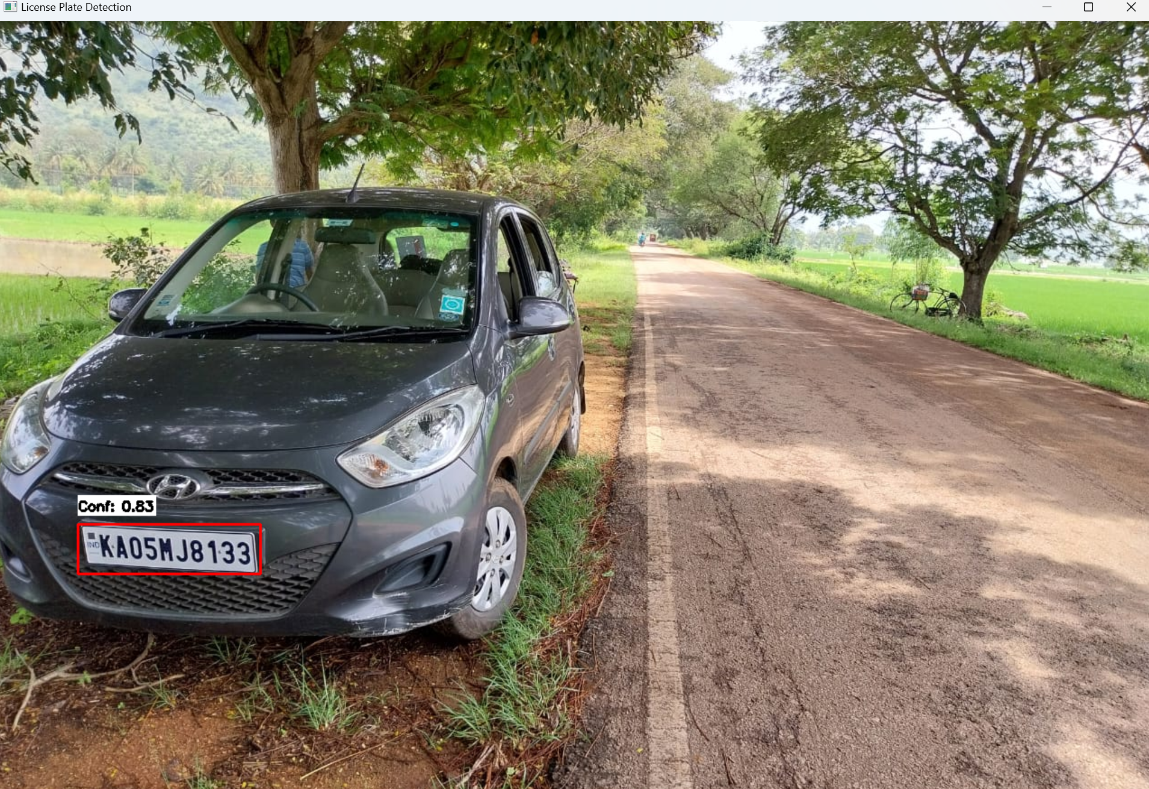

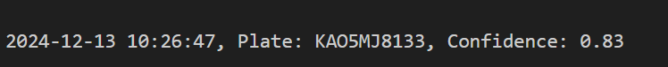

**7.2 Car Plate OCR**

Fig 7.1: Car Plate Detection

The above figure 7.1 shows the Plate Detection Module capturing the license plate of a stationary vehicle in a real-world scenario.

The above figure 7.2 shows the text being extracted from the above detection.

Fig 7.2: Car Plate OCR

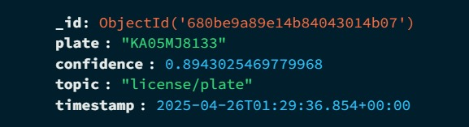

The above figure 7.3 shows the text being uploaded to MongoDb using MQTT.

Fig 7.3: Extracted Plate displayed in MongoDB

**7.3 Car Plates Uploaded**

# CHAPTER 8

**FUTURE ENHANCEMENT AND CONCLUSION**

# CHAPTER 8

**FUTURE ENHANCEMENT AND CONCLUSION**

# Future Enhancements

1. **Multilingual and Regional Plate Support**:
   * Extend recognition capabilities to support a variety of languages and plate formats, accommodating regional and international standards.
2. **Improved Environmental Resilience**:
   * Enhance the system's robustness under extreme conditions such as rain, fog, and poor lighting, using advanced preprocessing and data augmentation techniques.
3. **Cloud Integration for Scalability**:
   * Integrate cloud-based storage and processing for large-scale deployments, enabling real-time updates, analytics, and centralized data management.
4. **Edge Computing Support**:
   * Implement edge computing to process data locally, reducing latency and ensuring better performance in areas with limited internet connectivity.
5. **Integration with Traffic Systems**:
   * Develop APIs to communicate with existing traffic systems for real-time law enforcement and traffic management, including automated fine generation and traffic violation alerts.
6. **Data Privacy and Security**:
   * Incorporate robust encryption and access control mechanisms to secure sensitive license plate data and comply with privacy regulations.
7. **Hardware Optimization**:
   * Optimize the system to run efficiently on low-power devices, making it feasible for deployment on CCTV cameras or drones.
8. **Vehicle Classification**:
   * Add features to classify vehicles by type, color, or make, expanding its applications to include fleet management and enhanced security systems.

These enhancements will ensure that ALPERS remains relevant, scalable, and effective in meeting the evolving demands of modern transportation and security infrastructures.

# Conclusion

The Automatic License Plate Recognition System (ALPERS) successfully demonstrates the integration of deep learning models, such as YOLO, and optical character recognition (OCR) techniques through EasyOCR for detecting and recognizing license plates. The system achieves real-time detection with high accuracy, even in complex environments like urban traffic or parking lots. By automating tasks such as vehicle tracking, law enforcement, and parking management, it reduces human intervention and minimizes errors, offering a scalable solution to modern transportation challenges.

This project showcases the practical application of AI and image processing in solving real-world problems, emphasizing robustness and reliability in various conditions. Its modular design ensures adaptability for diverse environments, and potential integration with larger systems like traffic monitoring or security infrastructures.

# REFERENCES

# REFERENCES

**[1]** “Automatic License Plate Recognition (ALPR): A State-of-the-Art Review”, 2017

**[2]** License Plate Recognition using YOLOv4 and Deep Learning for Vehicle Tracking”, 2018

**[3]** “A Survey of License Plate Recognition Algorithms and Applications”, 2019

**[4]** OpenCV.org, **"OpenCV Documentation"**.

**[5]** J. Redmon, A. Farhadi, "YOLOv3: An Incremental Improvement," DOI: arXiv:1804.02767.

**[6]** I. Goodfellow, Y. Bengio, A. Courville, "Deep Learning," ISBN: 9780262035613.

**DAY WISE INTERNSHIP REPORT**

**Day 1**

**Session 1: Introduction to Cyber Security**

This session introduces the core principles of cybersecurity, including confidentiality, integrity, and availability (CIA triad). Learners explore various types of cyber threats like malware, ransomware, phishing, and denial-of-service attacks. It also covers the importance of secure passwords, regular updates, and firewalls. Real-life data breaches and their consequences are discussed. Emphasis is placed on both personal and organizational security practices. Learners will be introduced to cybersecurity terminologies and attack vectors. The session concludes with tips on staying safe online and the importance of cybersecurity careers.

**Session 2: Introduction to IoT**

The session provides an overview of how IoT connects the physical and digital worlds. It introduces the IoT architecture, including edge devices, cloud computing, and data analytics. Students will learn how sensors collect data and actuators perform actions. Practical applications such as smart homes, wearables, industrial automation, and agriculture are explored. Key IoT protocols like MQTT and HTTP are introduced. The session discusses challenges like power management, data storage, and latency. It ends with a look at future trends and innovations in the IoT space.

**Session 3: Introduction to Infosys Springboard / PicoCTF / Juice Shop / OWASP**

Learners are introduced to Springboard, a free platform offering tech certifications and career readiness. PicoCTF is discussed as a beginner-friendly Capture The Flag (CTF) game that teaches cryptography, forensics, and web security through puzzles. Juice Shop is introduced as a deliberately vulnerable web application to learn ethical hacking techniques. OWASP’s Top 10 is highlighted as a framework for understanding common web vulnerabilities like XSS and SQL injection. Hands-on demonstrations may include solving beginner CTFs or exploiting Juice Shop bugs. Learners are shown how to track their progress on these platforms. The session emphasizes the role of these tools in developing real-world skills.

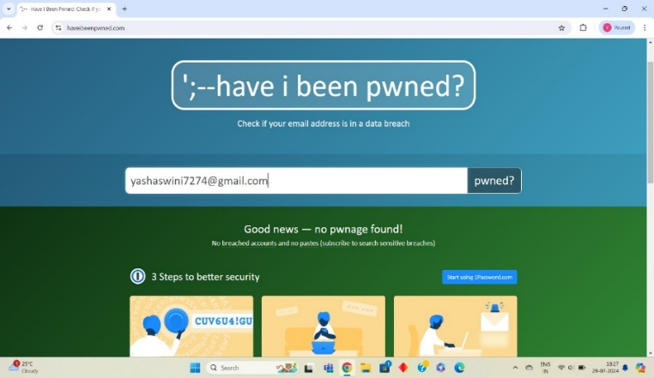

**Day 2**

**Session 1: Cybercrime Activities**

This session dives into common cybercrimes such as phishing, identity theft, online scams, and cyberbullying. Learners explore case studies involving financial fraud and data theft. The role of the dark web and anonymizing tools used by criminals is discussed. Students will analyze how cybercriminals exploit social media and open-source data. The psychological and financial impact of cybercrime on victims is also examined. Legal frameworks and laws against cybercrime in India and globally are introduced. The session concludes with prevention tips and reporting mechanisms.

**Session 2: Social Engineering**

Students learn how attackers manipulate individuals to gain confidential access. Various social engineering techniques such as pretexting, baiting, phishing, tailgating, and impersonation are explored. Real-life incidents are used to explain how even educated professionals can be victims. The session includes practical examples like fake tech support calls or spear phishing emails. Learners are taught how to identify social engineering red flags. Simulated scenarios may be used to test awareness. Strategies to build a security-aware culture are emphasized.

**Session 3: Google Find My Device, Have I Been Pwned, Call Masking**

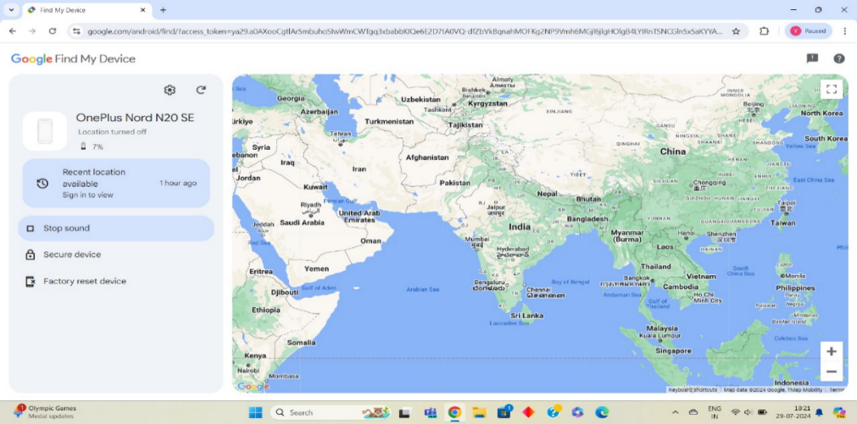This session covers practical tools for enhancing personal cybersecurity. Learners explore Google’s Find My Device for locating, locking, or erasing a lost Android device. Have I Been Pwned is used to check whether an email ID or password has been part of a data breach. Call masking is explained as a technique used to hide real phone numbers during communication, commonly used in ride-sharing or food delivery apps. The session includes demonstrations of using these tools. Learners understand the importance of monitoring digital footprints. Best practices for secure communication and password hygiene are also discussed.

**Day-3**

**Session 1: Vulnerabilities, Attacks, Attack Surface**

This session covers system weaknesses that can be exploited by attackers. Learners understand what constitutes an attack surface, such as user inputs, APIs, ports, and software interfaces. Different types of attacks—brute force, DDoS, SQL injection, etc.—are discussed. Real-world examples help explain the severity of each attack type. The importance of reducing the attack surface is emphasized. Learners also explore vulnerability scanning tools. The session concludes with prevention strategies like input validation, firewalls, and patching.

**Session 2: Computer Forensics, Cyber Forensics and Digital Evidence, Digital Forensic Life Cycle**

Introduces the field of digital forensics used to investigate cybercrimes. Learners study the digital forensic lifecycle: identification, acquisition, preservation, examination, analysis, and reporting. Real-world cases illustrate how digital evidence is gathered and used in legal investigations. The differences between computer forensics (focused on computers) and cyber forensics (broader digital space) are discussed. Students learn about chain of custody and the importance of maintaining integrity. Challenges such as encryption and anti-forensics are also covered. The session emphasizes the legal and ethical handling of data.

**Session 3: Simple Tools/Methods for Digital Forensics**

Students are introduced to basic forensic tools like Autopsy, FTK Imager, and Sleuth Kit. File carving, disk imaging, and metadata analysis are explained with demonstrations. They learn how to recover deleted files, view log files, and trace user activity. Simulations involve analyzing browser history, emails, and USB device usage. Learners also get exposure to timeline analysis to reconstruct cyber events. Open-source tools are preferred to encourage hands-on practice. The session builds confidence in basic forensic investigation skills.

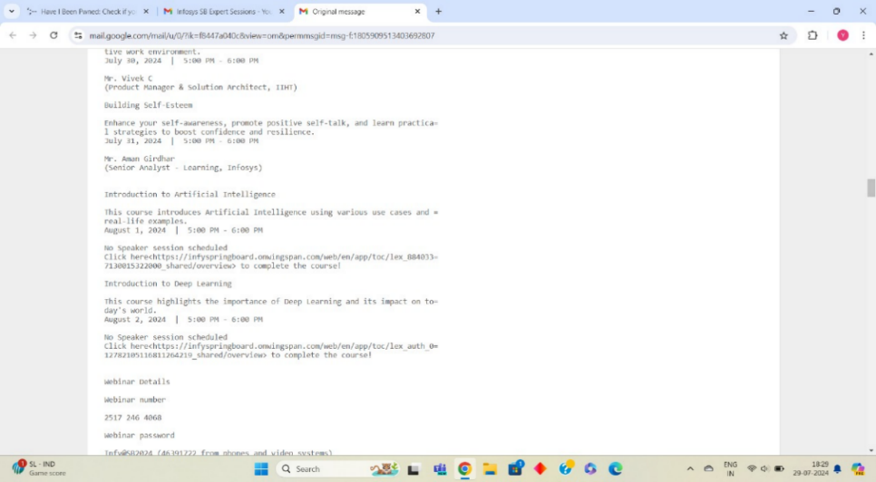

**Day 4**

**Session 1: Introduction to Cryptology**

This session explores the science of secure communication—cryptography. Learners understand the difference between symmetric and asymmetric encryption. Basic terms like plaintext, ciphertext, cipher, and key are introduced. Applications such as online banking, digital signatures, and secure messaging are discussed. Students learn how cryptology ensures confidentiality, authenticity, and integrity. Historical context helps in understanding how cryptology evolved. The session lays the foundation for modern cryptographic systems.

**Session 2: Math for Cryptology**

The mathematical backbone of cryptography is explained, including prime numbers, modulo operations, and Euler’s theorem. Learners perform modular arithmetic exercises to understand encryption logic. Concepts like GCD, totient functions, and multiplicative inverses are introduced. The RSA algorithm is briefly discussed in a simplified way. Real-world use of math in SSL/TLS, cryptocurrency, and authentication is highlighted. Students understand why strong cryptography depends on hard mathematical problems. The session includes hands-on problem-solving and quizzes.

**Session 3: World War 2 Ciphers (Enigma Machine, PURPLE)**

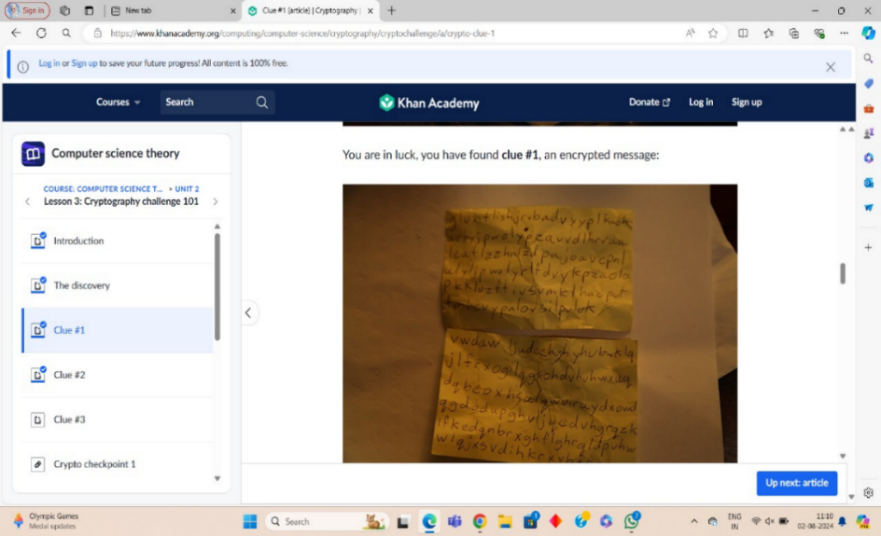Explores the cryptographic history of WWII, focusing on the German Enigma and Japanese PURPLE machines. Students learn how these machines encrypted military messages and how cryptanalysts broke them. Alan Turing’s contributions at Bletchley Park are discussed. Learners get to simulate simple rotor-based encryption methods. The role of cryptography in turning the tide of war is analyzed. The session highlights how breaking ciphers can change history. Connections are made between historical and modern encryption.

**Day 5**

**Session 1: Privacy and Digital Age**

Discusses why privacy matters in a hyper-connected world. Learners explore how data is collected through cookies, apps, social media, and IoT devices. Cases of surveillance capitalism and targeted ads are analyzed. The session discusses the balance between convenience and privacy. Tools like VPNs, private browsers, and tracker blockers are introduced. Students reflect on their digital footprint. The session encourages critical thinking about online habits and privacy trade-offs.

**Session 2: Compliance**

Learners are introduced to global data protection laws such as GDPR (Europe), HIPAA (US), and CCPA (California). These laws define how organizations must collect, store, and use personal data. Compliance reduces risk, ensures trust, and avoids penalties. The session covers key terms like data controller, processor, consent, and breach notification. Tools and audits for maintaining compliance are explained. Learners examine privacy policies of real companies. The importance of ethical data handling is emphasized.

**Session 3: Small Case Study with Compliance**

Students analyze real-world cases like Facebook–Cambridge Analytica or Google’s GDPR fine. They identify what went wrong, which compliance rules were violated, and what actions followed. Discussion includes the roles of legal teams and data protection officers. Learners practice spotting non-compliance in sample policies or scenarios. They simulate writing compliance reports or designing checklists. The session reinforces how theory translates into real-world application. Group work encourages critical analysis and communication skills.

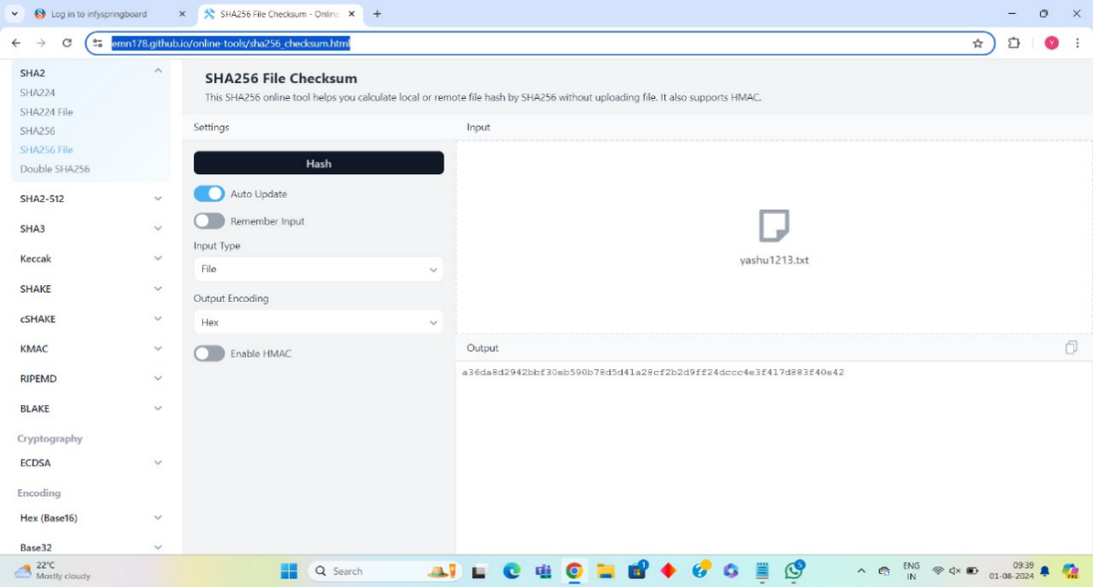

**Day 6**

**Session 1: Privacy**

This session delves deeper into digital privacy risks and the concept of informed consent. Students learn how tracking mechanisms like cookies, fingerprinting, and data brokers operate. The difference between anonymity, pseudonymity, and full identity is discussed. Privacy breaches in major companies are examined. Students explore how compromised privacy affects freedom and safety. Tips for minimizing data exposure are shared. Ethical dilemmas around data sharing are also explored.

**Session 2: DPDA / Indian Laws**

Focuses on India’s evolving digital privacy laws such as the Digital Personal Data Protection Act (DPDP). Learners understand key principles like lawful processing, purpose limitation, and user rights. Comparisons are made with international laws like GDPR. Government vs. private sector data collection is debated. The role of the Data Protection Board and grievance redressal mechanisms is introduced. The session covers penalties for non-compliance. Students are encouraged to read sections of the actual act.

**Session 3: Singapore Law (PDPA)**

Covers the Personal Data Protection Act of Singapore and how it applies to organizations. Learners explore the 9 data protection obligations, such as consent, accuracy, and security. Real enforcement cases by Singapore’s PDPC (Personal Data Protection Commission) are discussed. Comparisons are made with Indian and global laws. Students assess how cross-border data flow is regulated. Penalties for breaches and audit practices are reviewed. The session encourages understanding of Asia-Pacific privacy regulations.

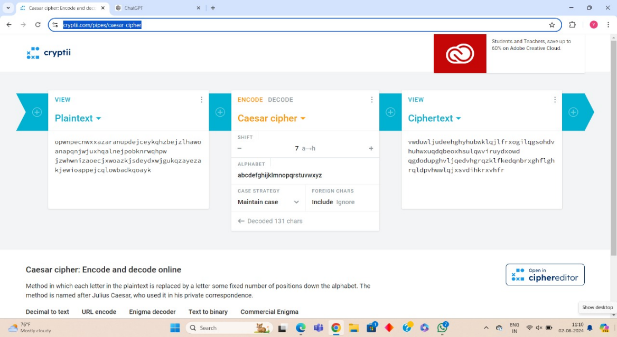

**Day 7**

**Session 1: Introduction to Classical Cryptography**

Students are introduced to ancient encryption techniques used for secure messaging. Ciphers like Caesar and Vigenère are demonstrated with pen-and-paper encryption. Limitations of classical methods are discussed, including frequency analysis and brute force attacks. Learners explore how these ciphers laid the foundation for modern systems. Historical examples like Roman and Spartan cryptography are presented. Hands-on exercises reinforce learning. The session highlights why strong math is needed for unbreakable ciphers.

**Session 2: Substitution Cipher**

A substitution cipher replaces each letter with another based on a rule or key. Learners explore simple and monoalphabetic ciphers, including Atbash and ROT13. Students encrypt and decrypt messages using different substitution schemes. The vulnerabilities of fixed substitutions (like letter frequency) are explained. Historical usage in military and spy communications is discussed. Exercises include cracking a message using frequency tables. The session builds problem-solving and pattern recognition skills.

**Session 3: Transposition Cipher**

A transposition cipher rearranges letters of the plaintext based on a pattern. Learners explore types like columnar transposition and rail fence cipher. They practice encoding and decoding messages with grid patterns. Differences between substitution and transposition are clarified. Security of transposition ciphers depends on complexity of rearrangement. Students also attempt to break weak transposition ciphers using brute force. The session includes puzzles and cryptographic games to reinforce concepts.

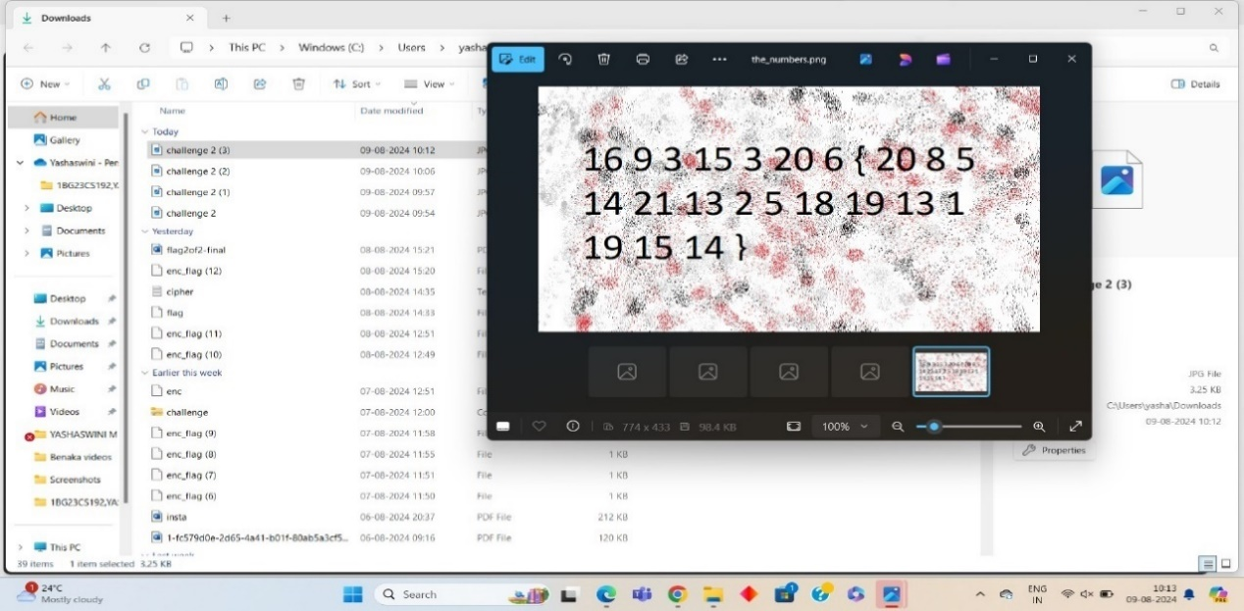

**Day 8**

**Session 1: Ethical / Unethical Hackers, Motivation, Objectives**

This session explores the difference between white hat, black hat, and grey hat hackers. Learners discuss the motivations behind hacking—curiosity, activism, financial gain, or revenge. Famous hackers like Kevin Mitnick and Anonymous are studied. The role of ethical hackers in penetration testing and defense is emphasized. Legal and ethical boundaries are explained. Learners understand certifications like CEH (Certified Ethical Hacker). The session promotes responsible use of skills.

**Session 2: How Criminals Plan the Attacks**

Students learn the cyberattack lifecycle—reconnaissance, scanning, gaining access, maintaining access, and covering tracks. Tools like Nmap, Shodan, and Metasploit are introduced conceptually. Attack planning via phishing, malware, and credential harvesting is discussed. Learners analyze real attack scenarios and threat actor behaviors. Red team vs. blue team simulations may be introduced. The importance of social engineering in planning is emphasized. The session reinforces how critical awareness is in cyber defense.

**Session 3: IoT Arduino ESP32**

Introduction to ESP32 microcontroller used in IoT for Wi-Fi and Bluetooth-based applications. Students learn about GPIO pins, sensors, and actuators controlled by ESP32. Simple Arduino IDE programs are written to blink LEDs or read sensor data. Applications include home automation, weather stations, and IoT alarms. The differences between ESP32 and Raspberry Pi are explained. Learners understand how to connect ESP32 to cloud services. The session builds practical hardware and coding skills.

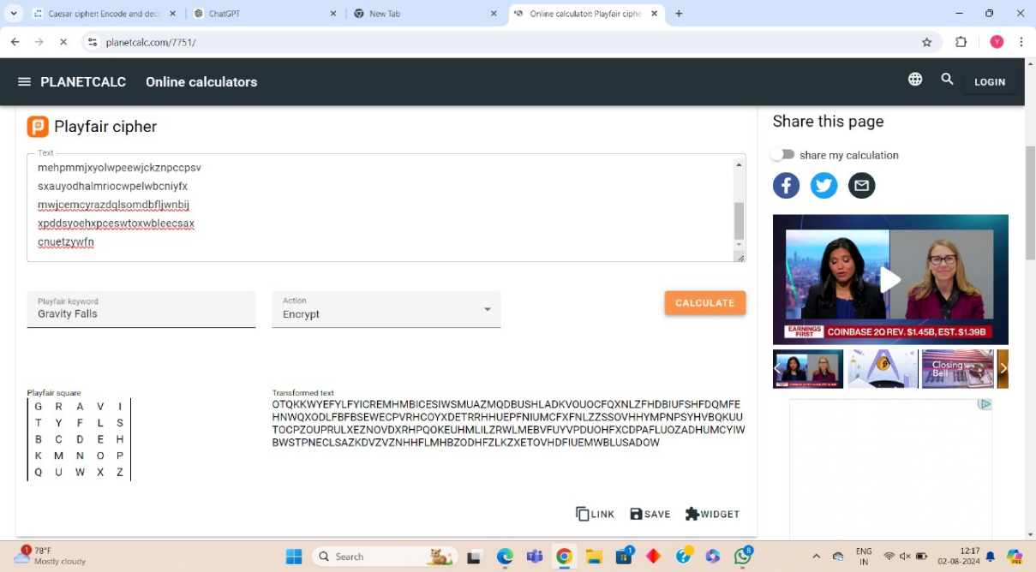

**Day 9**

**Session 1: Raspberry Pi Board**

Learners explore the Raspberry Pi’s components—CPU, RAM, GPIO, USB, HDMI, etc. It is presented as a low-cost computer used for DIY electronics and learning. Students install and use Raspberry Pi OS. Basic Python scripts are run on the Pi. Differences from Arduino and its Linux-based nature are discussed. Learners are guided through real project ideas like media centers, sensors, or robots. Hands-on experience is encouraged wherever possible.

**Session 2: Sensors**

Covers input devices used to detect environmental conditions. Sensors like DHT11 (temperature/humidity), PIR (motion), IR (obstacle), and gas sensors are introduced. Learners connect sensors to Raspberry Pi or Arduino and read values using Python or C code. Use cases in agriculture, smart homes, and security systems are discussed. Calibration and accuracy considerations are explained. Students are encouraged to build mini-projects with multiple sensors. The session includes a demo or simulation.

**Session 3: Actuators**

Focuses on output devices that perform actions in response to sensor data. Examples include LEDs, motors, buzzers, and servos. Learners program simple actuation like blinking, turning a motor, or activating a buzzer on detection. Use cases like automatic doors, alarms, and smart fans are discussed. Concepts of power supply and PWM (Pulse Width Modulation) are introduced. Wiring diagrams and safety tips are shared. The session reinforces the sensor-to-action loop in IoT.

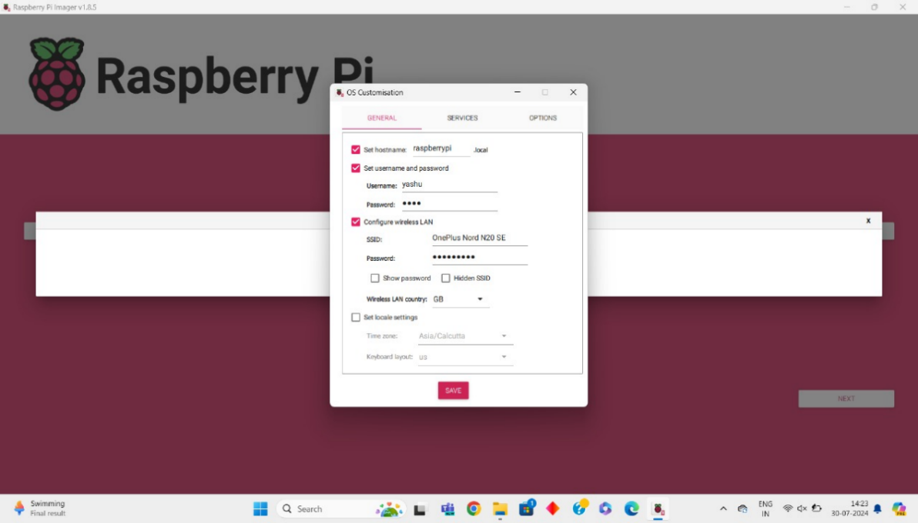

**Day 10**

**Session 1: IoT Attack Surfaces, Vulnerabilities**

Explores the unique security challenges of IoT devices. Learners identify common attack surfaces: insecure interfaces, default credentials, unpatched firmware, and weak communication protocols. Case studies like Mirai botnet are discussed. Vulnerability scanning and threat modeling for IoT are introduced. Learners reflect on securing their own IoT projects. Best practices for device hardening are covered. The session emphasizes proactive security in device design.

**Session 2: IoT Data Communication**

Covers how devices talk to each other and the cloud using protocols. Students learn about MQTT, CoAP, HTTP, and WebSockets. Real-world examples like sending sensor data to a dashboard are demonstrated. Message formatting using JSON or XML is discussed. Issues like latency, bandwidth, and reliability are considered. Tools like Node-RED or ThinkSpeak may be introduced. The session reinforces data flow and protocol choice in IoT systems.

**Session 3: Integrating Pi Camera**

Learners explore how to connect and program the Raspberry Pi Camera module. Applications like surveillance, image capture, and motion detection are discussed. Students write Python scripts using OpenCV to take photos or stream video. Face detection and object tracking basics are introduced. Security use cases such as anti-theft systems are explored. Learners troubleshoot common camera setup issues. The session encourages creativity in IoT vision projects.

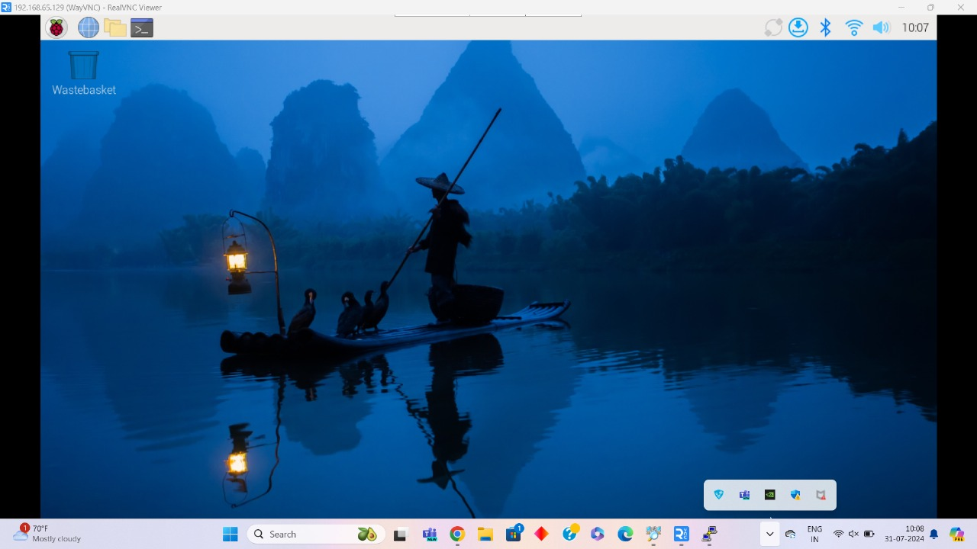

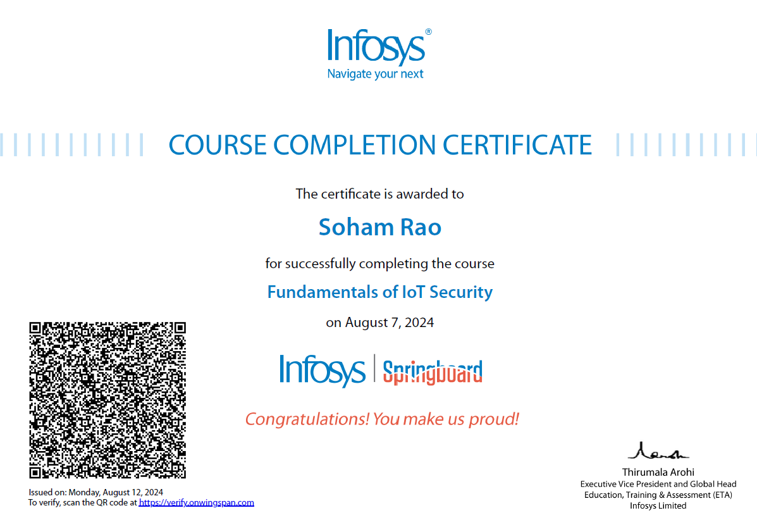**COURSE COMPLETION CERTIFICATES – SOHAM RAO(1BG23CS154)**

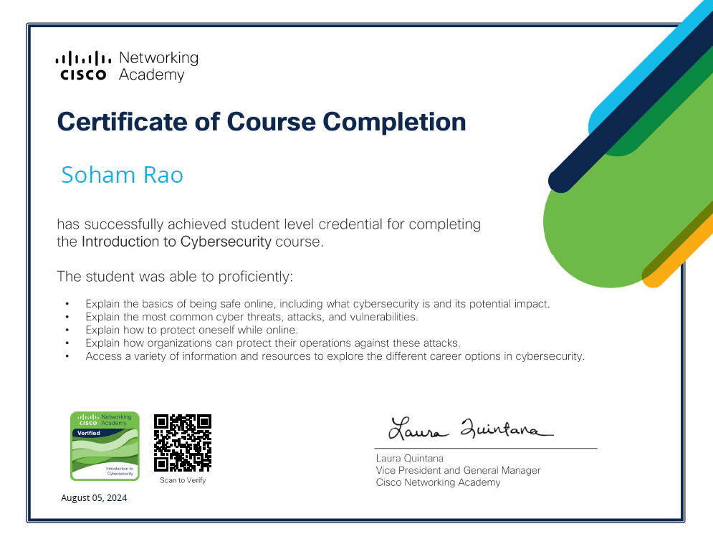

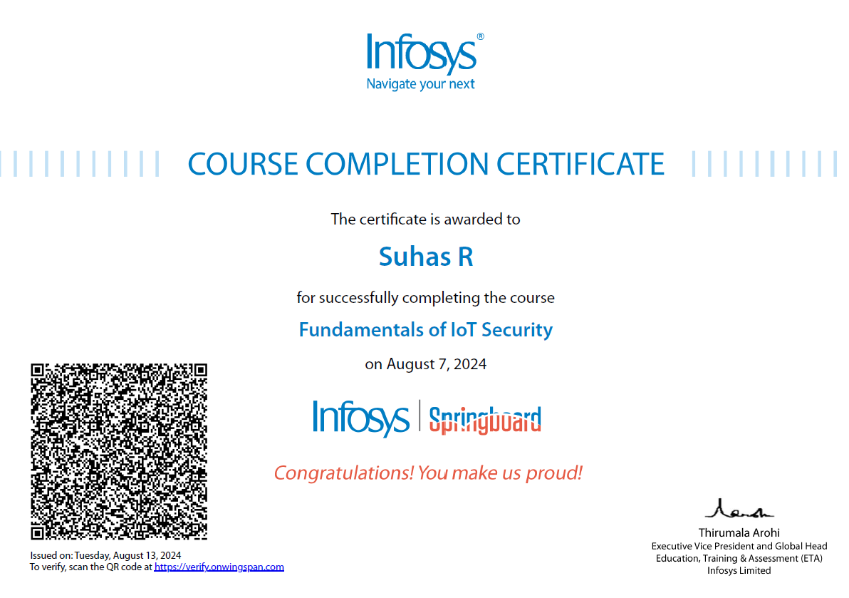**COURSE COMPLETION CERTIFICATES – SUHAS R(1BG23CS162)**

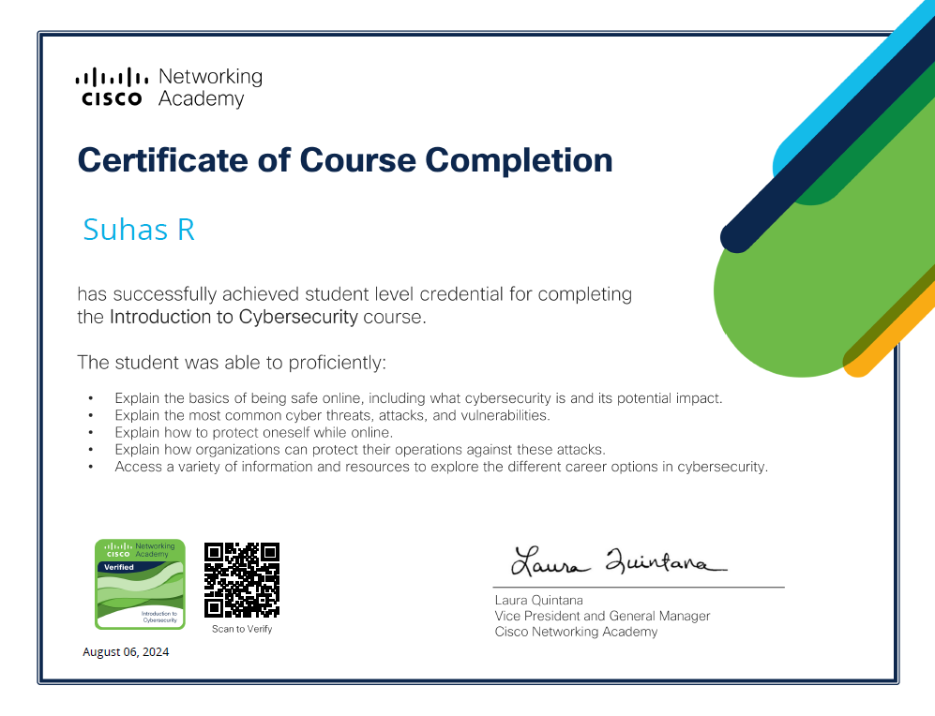

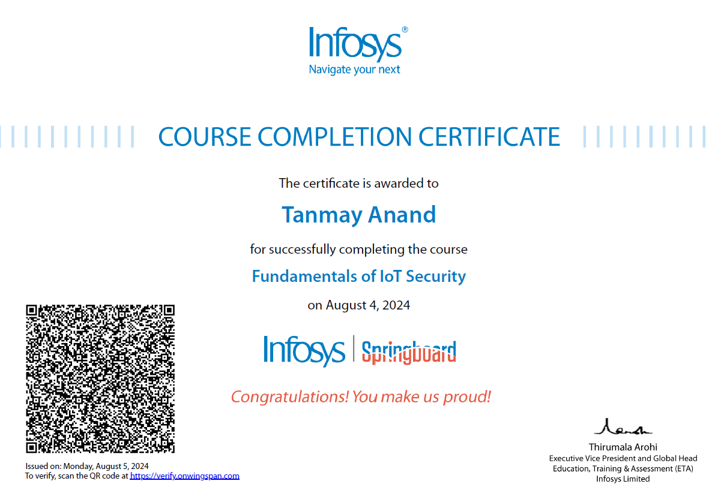**COURSE COMPLETION CERTIFICATES – TANMAY ANAND(1BG23CS168)**

